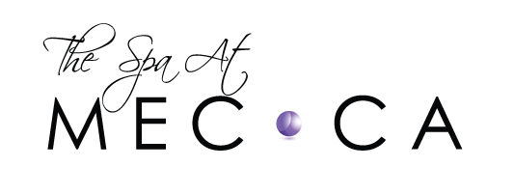
AQUAGOLD® MICRONEEDLING CONSENT FORM
Aqua Gold is based on the skin’s natural ability to repair itself. Aqua Gold treatments create superficial “micro-channels” to the outermost layer of the skin, inducing the healing process including new collagen production. Aqua Gold has been shown to reduce the visibility of acne scars, fine lines, and wrinkles, diminish hyper pigmentation, and improve skin tone and texture.
I hereby authorize The Spa at Mecca and the appointed physician to perform my Aqua Gold treatments. I consent to Aqua Gold treatment containing Botox micro units, HA, and possible growth factors.
I understand possible side effects include and are not limited to: slight or extreme redness, histamine reaction, swelling, stinging, itchy, tender, dry or flaking skin. In rare instances, hyper pigmentation/hypo pigmentation, scarring, nodule formation, or infection can occur. I understand that I should only apply products recommended by my clinician post treatment.
Most side effects will gradually diminish over time as healing may take several days. Notify your clinician if any side effects cause extreme discomfort or any unexpected problems occur immediately.
I have avoided the following products/procedures THREE DAYS prior to treatment:
- Topical prescriptions including but not limited to Retin-A, Tretinoin, Differin, Tazorac
- Abrasive scrubs or other exfoliating products
I have not had any cosmetic injections within the last TWO WEEKS.
Notify your physician PRIOR TO SIGNING THIS CONSENT if any of the following apply to you:
- Cold sores(or history), warts, open skin lesions, sunburn, extreme sensitivity, dermatitis, rosacea
- Blood thinning medications
- Accutane or generic within the past year
- Pregnant or breastfeeding
- Received chemotherapy or radiation therapy
- Collagen Vascular Disease
- Eczema, Psoriasis, or Dermatitis
- Hemophilia / bleeding disorders
- Keloid/hypertrophic scaring
- History of autoimmune disease or any condition that may weaken your immune system
I am undergoing treatment of my own free will. I agree that this procedure is being performed for cosmetic reasons and that no guarantee can be made as to the exact results of this procedure. I understand that although I may see a change after my first treatment; I may require a series of sessions to obtain my desired outcome. The procedure contraindications, precautions and warnings have been explained to me including alternative methods; as have the advantages and disadvantages. I am advised that though good results are expected, the possibility and nature of complications cannot be fully anticipated. Multiple treatments may be necessary to achieve optimal results.
ACKNOWLEDGMENT: By my signature below, I certify that I have read and fully understand the contents of this Aqua Gold consent form and that the disclosures referred to herein were made to me.

Note: Prices are subject to change without notice

Client’s Name (Printed):

Client’s Signature:

Date:

